**Downloading the Python Reddit Scraper:**

This script can be found on github at the following link:

[jblenfestey/pythonredditscraper: Reddit Web Scraper Using Python (github.com)](https://github.com/jblenfestey/pythonredditscraper)

**Using the Python Reddit Scraper:**

Python is required to run this script and was written using python version 3.9.9.

This script requires the following to be installed using pip: praw, pandas, numpy, and openpyxl.

* (Can be done by opeing up powershell and typing in: pip install praw, pip install pandas, pip install numpy, and pip install openpyxl . See screenshot for example of pip installing praw.)

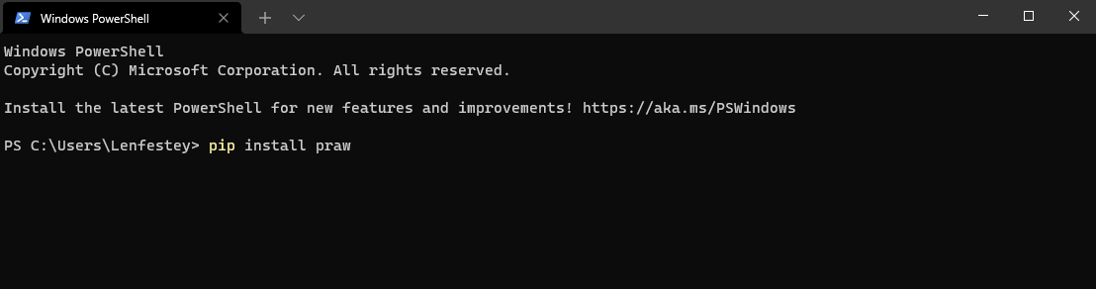

Once those have been installed, navigate to github and download code zip folder by **clicking the green code button** then selecting **download zip**. This will download the code as a zip file to your downloads folder. ([jblenfestey/pythonredditscraper: Reddit Web Scraper Using Python (github.com)](https://github.com/jblenfestey/pythonredditscraper) )

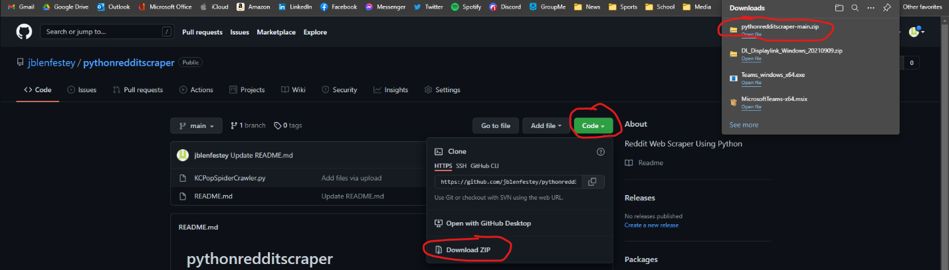

In the downloads folder, **right click** the zip file and select **extract all**…

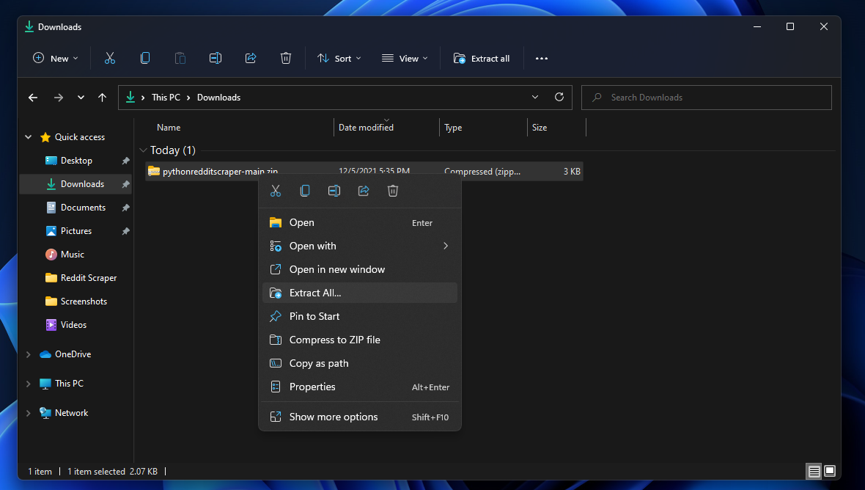

On the next pop up window select extract at the bottom right of the window.

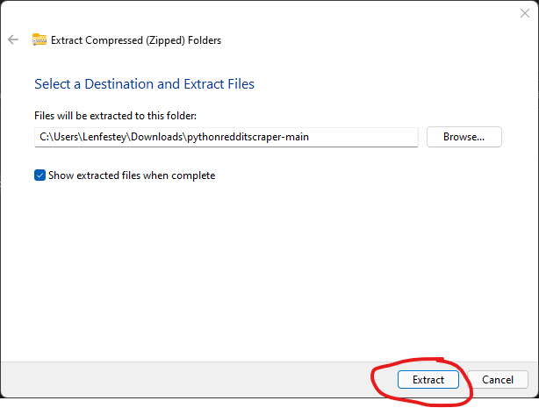

This will create a new folder that will have our script in it.

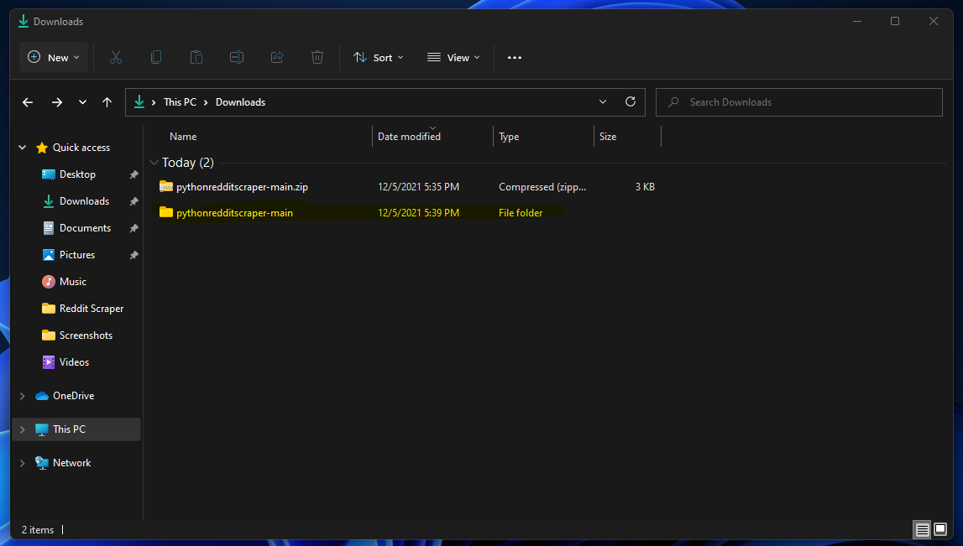

Open the new folder and the folder it contains and you will see the .py script we will be working with.

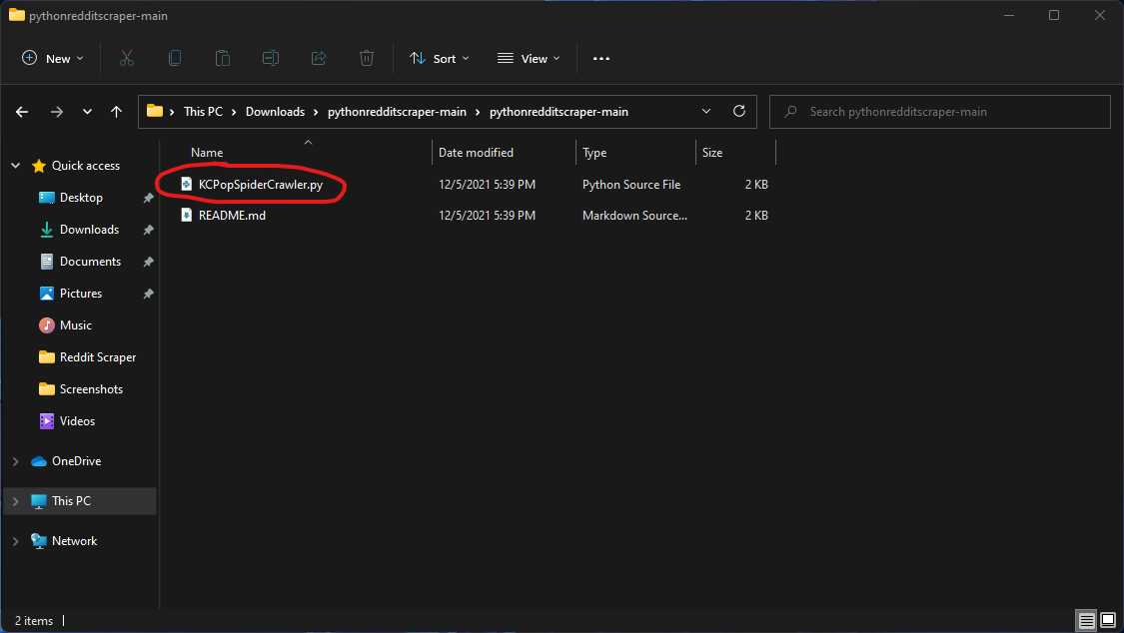

You can run to KCPopSpiderCrawler.py in an IDE like Visual Studio Code or in PowerShell.

For our example, we will run it in PowerShell by navigating to the folder that has our script in it and run it by typing "python .\KCPopSpiderCrawler.py"

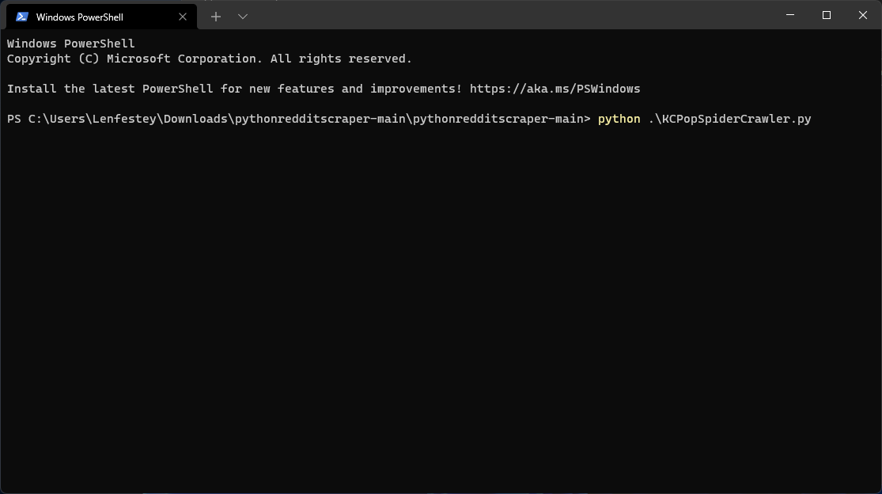

The application will run and display the results in the terminal and it will also create two CSVs in the folder that the .py script is located in.

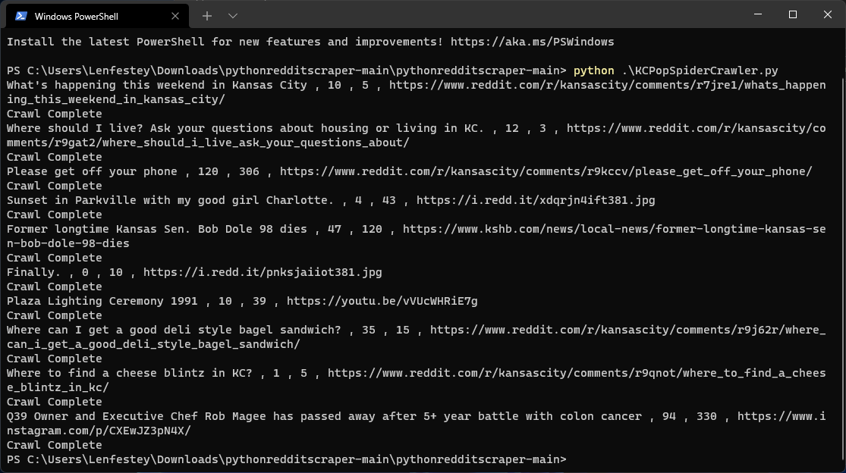

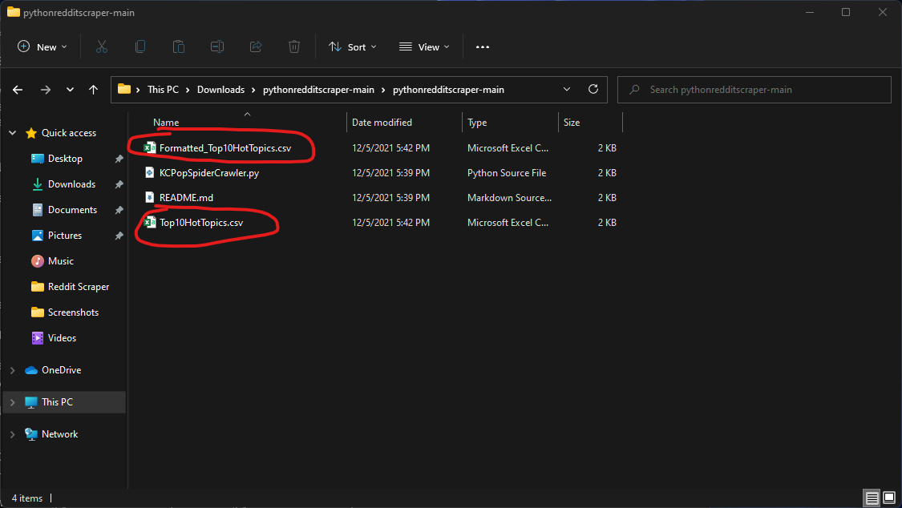

The CSV labeled Formatted is the best way to read the data collected.

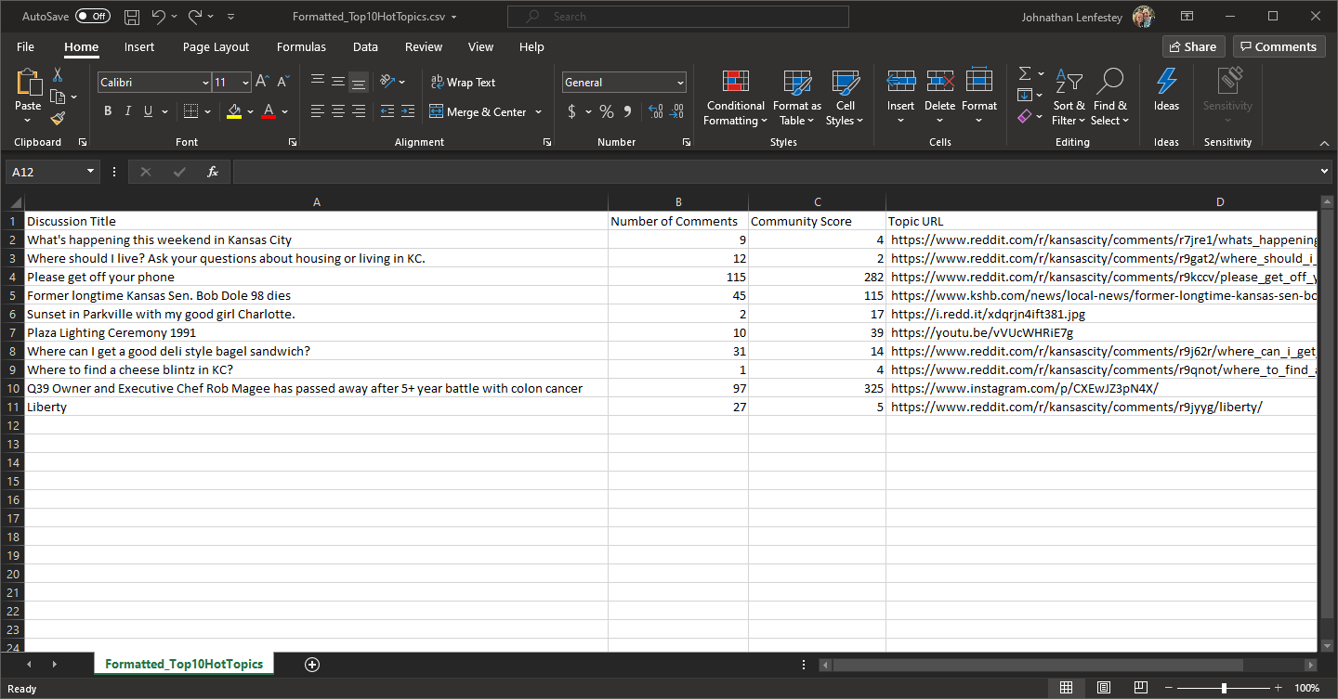

This script can be manipulated to scrape other subreddits.

In our case, we are pulling the weekly hot posts from the Kansas City subreddit. We could change this to hot posts of today, or the year. We could even change from hot posts to top, new, or rising if we wanted to.

This can be done by modifying “subs = reddit.subreddit('kansascity').hot(limit=10)” in the code. 

**Know Errors:**

If you run the program and have one of the excel spreadsheets that will be modified open, you will get an error letting you know to close the application and try again.

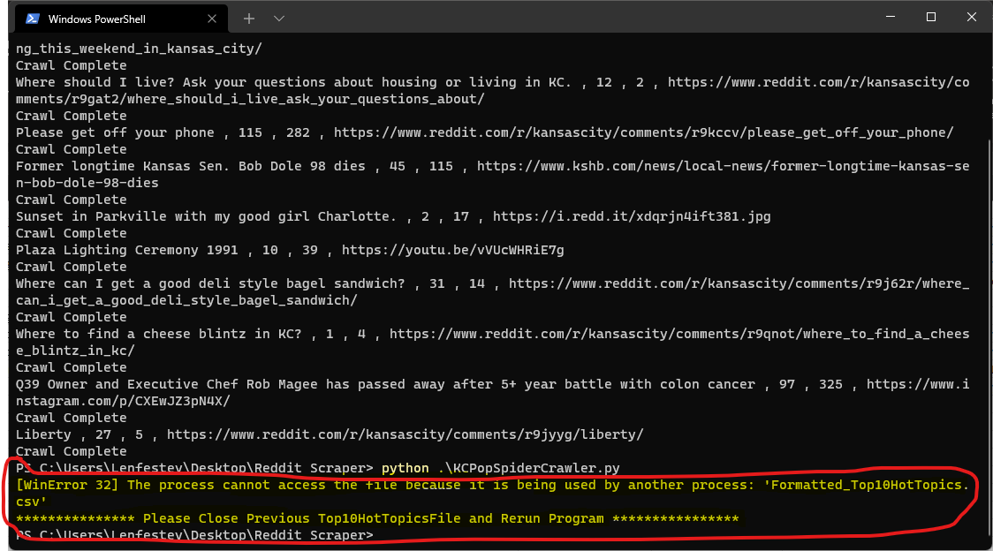

Once the sheet is closed then the program will run like normal again.